Intraspecific variation in germination strategies correlate with variation in precipitation and reproductive failure in *Clarkia xantiana*

Bjorn Larson

Professor Vince Eckhart

10 August 2020

**Abstract**

Species distribution models improve when physiological limits and intraspecific niche variation are incorporated into the models. Seed germination physiology plays an important role in determining the distribution of plant species and has been shown to undergo local adaptation. I carried out a germination experiment using the hydrotime model of seed germination to estimate germination fraction, hydrotime and mean base water potential for eight populations of *Clarkia xantiana* ssp. *xantiana* that experience different environmental conditions and demography. While seed germination traits were independent of mean precipitation, hydrotime appeared to correlate with variation in precipitation, and dormancy was higher in populations that had experienced reproductive failure at least once over a fifteen-year span. These findings demonstrate probable local adaptation in seed germination physiology within a species, which is relevant to understanding plant species distributions and predicting future distributions as habitats undergo climate change.

**Introduction**

Developing mathematical or statistical models that predict the distribution of species has been a goal of ecological research since the 1970s (e.g., Gauch & Whittaker, 1976; Austin, 1980). Since then, expansions in computing power and spatial ecological data have led to similar expansions in the methods of species distribution modelling (Zimmerman et al., 2010). One of the most important changes that has come about in the past 50 years is the development of forecasting techniques that allow researchers to predict future species distributions (Wiens et al., 2009). Due to anthropogenic effects on climate and land use, many species will face changes in habitat availability in the future. Creating models that can predict the effects of these changes will be vital as we try to preserve species and habitats.

Most models of species distribution currently attempt to capture either a species’ realized niche or its fundamental niche (Morin & Lechowicz, 2008). The most common models at present are correlational models, which take environmental information about where a species currently occurs and determine locations with similar environmental conditions now or in the future (e.g., Phillips et. al, 2006; Parolo, Rossi, & Ferrrarini, 2008; Pérez & Font, 2012). These rely on the realized niche model first introduced by Grinnell (1917), inferring the niche from the known habitat. More rarely, investigators try to understand a species’ niche by experimentally determining limits to the survival and reproduction of the species across ranges of different conditions, following the Hutchinsonian idea of the fundamental niche (1957). In this approach, one infers the potential distribution from the known niche. Calls for a hybrid approach (e.g., Morin & Lechowicz, 2008; Pearman et al., 2010; Dormann et al., 2012), where physiological restrictions are integrated into correlational models, have generated successful hybrid models of species distributions in butterflies and lizards (Buckley et al., 2011), and in corals (Rodriguez et al., 2019). These hybrid models have predicted range expansion and contraction more successfully than purely correlational models, as they can include fundamental limits to a species’ range (Buckley et al., 2011).

Distribution modelling also improves when researchers acknowledge that a species’ ecological niche is composed of the niches of its geographically separate populations, which may not have identical fundamental niches (Peterson & Holt, 2003; Holt, 2009). Intraspecific niche divergence has been observed in a wide variety of species and contexts (e.g., Rehfeldt et al., 1999; Peterson et al., 2003; Pfenninger et al., 2007). Wright et al. (2006) showed that there was significant niche divergence of *Collinsia sparsiflora*, an annual flowering plant,at scales as small as hundreds of meters. Researchers have debated whether this geographic niche divergence is due to local adaptation (Wright et al., 2006) or whether it simply appears in correlational models due to regional differences in available habitat (Murphy & Lovett-Doust, 2007). However, with the rise of physiological inputs into species distribution models, it is important that the inputs represent the potential diversity that could exist below the species level.

One key process that underlies the fundamental niche of seed plants is the response of seed germination to precipitation. Germination has often been linked to differences in post-germination traits that are subject to local adaptation (Schupp, 1995). However, germination traits are also influenced by natural selection on their own (Donohue et al., 2010). For example, Arène et al. (2017) showed that variation in threshold “base” water potential necessary for germination is a labile trait, able to adapt on relatively short time scales to local conditions. Base water potential (*Ѱ*b[*g*]) describes the threshold water potential required for germination of a certain percentage of seeds, *g* (Bradford, 1990). According to the Bradford model, *Ѱ*b is a normally distributed trait among seeds of a specific population, with a mean *b* and standard deviation The related concept of hydrotime (θH) refers to the dependence of germination on the duration of water availability. In annual species of *Brassica* (mustard), Castillo-Lorenzo et al. (2019) found that populations from drier climates tend to germinate at higher water potentials (“wetter” soil, essentially) than those from rainier climates, while hydrotime was not as significantly correlated with rainfall. The researchers suggest this is evidence of local adaptation, as plants from drier climates are less willing to risk germinating without experiencing significant rainfall events. In addition, Volis et al. (2002) found that strategies for exiting the seed bank vary significantly according to local conditions, with seeds from less productive areas with more variable rainfall showing lower germination fractions, which they argue is evidence for “bet-hedging” (i.e. lower germination fraction in any particular year in order to spread the risk of reproductive failure over multiple years). These examples suggest that in a species with significant variation in precipitation across the range, there is likely associated variation in base water potential and other germination traits, as populations adapt to their local conditions.

I investigated geographic variation in various seed germination traits among populations of the annual plant *Clarkia xantiana* ssp. *xantiana*, native to California. This species has been proposed as a model organism for understanding ecological niches and geographic ranges (Eckhart et al., 2011; Gould et al., 2014). Precipitation is highly variable across the species’ range, and it limits distribution at scales of tens of kilometers (Eckhart et al. 2011). Meanwhile, soil water potential affects adult plant performance and density at scales of meters (Eckhart et al., 2010; Kramer et al., 2011; Eckhart et al., 2017). Gould et al. (2014) determined that the adult plants of *C. xantiana* have many traits that are genetically variable among populations and seem to be adaptive to local climates, but it is unknown whether similar genetic variation and local adaptation also occurs in seed germination. Recent work (Geber, Moeller, & Eckhart, unpublished data; R. Snodgrass, unpublished data; James et al., 2020) suggests that the seed germination stage is a critical missing piece in understanding the physiological limits and fundamental niche of this species.

In my experiment, I addressed two questions: 1.) Is there intra-specific variation in seed germination traits that suggests that different germination strategies have evolved? 2.) If there is intraspecific variation, can it be explained by features specific to the populations, including environmental conditions and demography? I expected that there would be variation in all three traits; germination fraction, hydrotime, and base water potential, between populations. Additionally, I expected that populations that experience lower, more variable precipitation and populations that have experienced reproductive failures would have higher base water potential and lower germination fraction as a bet-hedging strategy.

**Methods**

*Study System* I used seeds from eight populations across the range of *C. xantiana* ssp. *xantiana* (Fig. 1). These populations live on slopes between elevations of 530 and 1300 m, in sandy soils of either igneous or metasedimentary origin (Eckhart et. al, 2017). They also vary in regard to climatic variables of temperature and precipitation (Eckhart et. al, 2011). Data on environmental characteristics and demography were collected over a fourteen-year period from 2005-2018 with remote sensors and annual censuses across the range of the species. (See Appendix A for environmental data from each population.)

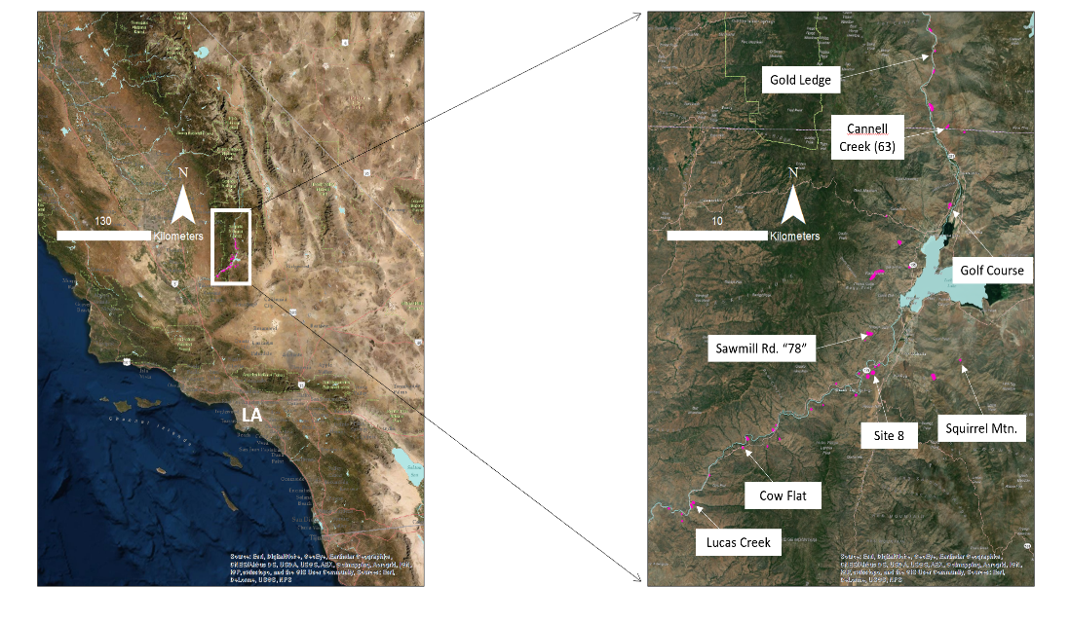**Figure 1:** Location of sample populations within the species’ range.

*Experimental Design*

The experimental design and analysis were modelled after Bradford et al. (1990). To determine the seed germination traits for each population, I measured the germination rate of seeds from the above populations in eight different water potentials. Seeds were placed on germination paper (Seedburo Equipment Company, Des Plaines, IL, USA) in eight petri dishes, which corresponded to eight different water potential treatments, ranging from 0 to -0.35 MPa in 0.05 MPa increments. To create the different water potential treatments, I saturated each germination paper with a solution of deionized water and varying amounts of polyethylene glycol (Bradford, 1990). I used data from pilot experiments to determine that optimal saturation for seed development was at 6.25 mL per paper. I measured germination every eight hours, and terminated the experiment after 336 hours, or 14 days. If seeds had not germinated after 336 hours, I used a squeeze test to determine whether the seeds were viable (Baskin and Baskin, 2014). The experiment was replicated three times over the course of two months. The seeds received ambient light and ambient basement temperature, which was measured using a data-logging thermometer (Onset, Bourne, MA). The temperature varied between the first replicate and the second two, with the first averaging 20.4°C, the second averaging 17.9°C, and the third averaging 17.5°C.

*Data Analysis*

I combined the data from the second and third replicates for analysis. I did not include data from the first replicate, as total germination was less than half that of the others, likely due to the much higher temperatures. Smith-Huerta (1984) showed that many *Clarkia* species had significant reductions in germination fraction at temperatures above 20°C, and pilot experiments showed that temperatures below 20°C significantly increased the germination fraction.

The experiment generated three variables that describe the water relations of seed germination. I determined final germination fraction (fraction of viable seeds germinated) for each water potential population treatment. Additionally, the complete germination time courses for each water potential treatment were analyzed in order to determine hydrotime and mean base water potential using the formulas in Bradford (1990). I calculated for each population using repeat probit analysis, and used the resulting regression line to determine for each treatment (For a detailed analysis of the Bradford model and how I applied it to these data, see Appendix B). I analyzed the time courses for each replicate separately and took the mean of each calculated germination trait (Huang et al., 2016; Castillo-Lorenzo et al., 2019), with the exceptions of the Corral Creek and Squirrel Mountain populations, which each only had one replicate. The Squirrel Mountain population germinated at rates too low to carry out probit analysis (Appendix B). Therefore, germination fraction was the only response variable for this population.

To identify local adaptation in germination traits, I performed a range of statistical analyses on the data extracted from the germination time courses. First, I analyzed final germination fraction using a two-way ANOVA with population and water potential as factors. The population term estimated intraspecific variation, while the water-potential term was expected to reveal reduced germination at declining water potentials. A significant interaction term would indicate that population germination fractions decreased at different rates with declining water potential. Second, I used one-way ANOVA to analyze variation in the other germination traits among populations. Third, I calculated correlation coefficients between germination functional traits ( and , as well as the fitted mean of final germination fraction from the two-way ANOVA) and selected environmental traits: mean winter (November-January) precipitation, mean spring (February-June) precipitation, and the coefficient of variation of spring precipitation. I also performed t-tests to compare the seed germination traits of populations that experienced reproductive failures (i.e., no new seeds in at least one growing season between 2006 and 2018) and those without. Probit analysis was carried out using Excel (Office 365 Version 2002) and regressions and other data analyses were carried out in Minitab 19.1.0.0.

**Results**

The final germination fraction varied across populations and decreased significantly at lower water potentials (Fig. 2; Fig. 3). Germination fraction varied from 0.91 in the Cow Flat population to 0.33 for the Squirrel Mountain population (F[8,56] = 13.29; p < 0.001; Fig. 2). Germination fractions were above 0.7 for ambient water potentials above -0.25 MPa, but declined as water potential dropped, ending below 0.4 at -0.35 MPa (F[7,56] = 20.99; p <0.001; Fig. 2). There was no evidence of interaction between population and water potential; populations responded similarly to variation in water potential (F[7,56] = 0.86; p = 0.719).

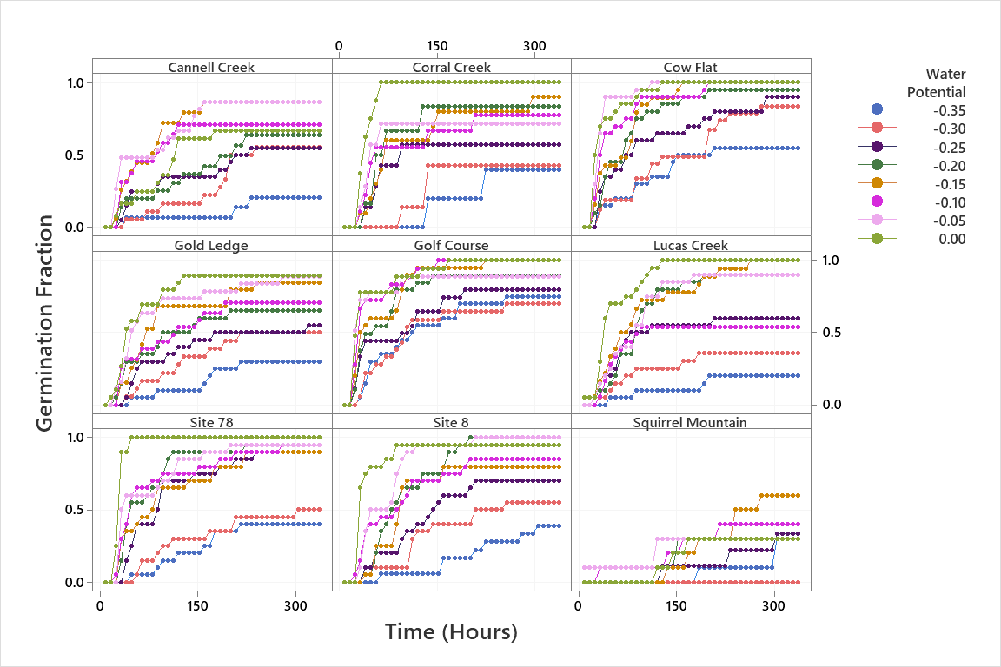

**Figure 2:** Time courses of germination fraction for each population and water potential. Germination fractions are means of two replicates, with the exceptions of the Corral Creek and Squirrel Mountain populations, which only had one. replicate. N = 10 for each populationwater potential treatment, per replicate

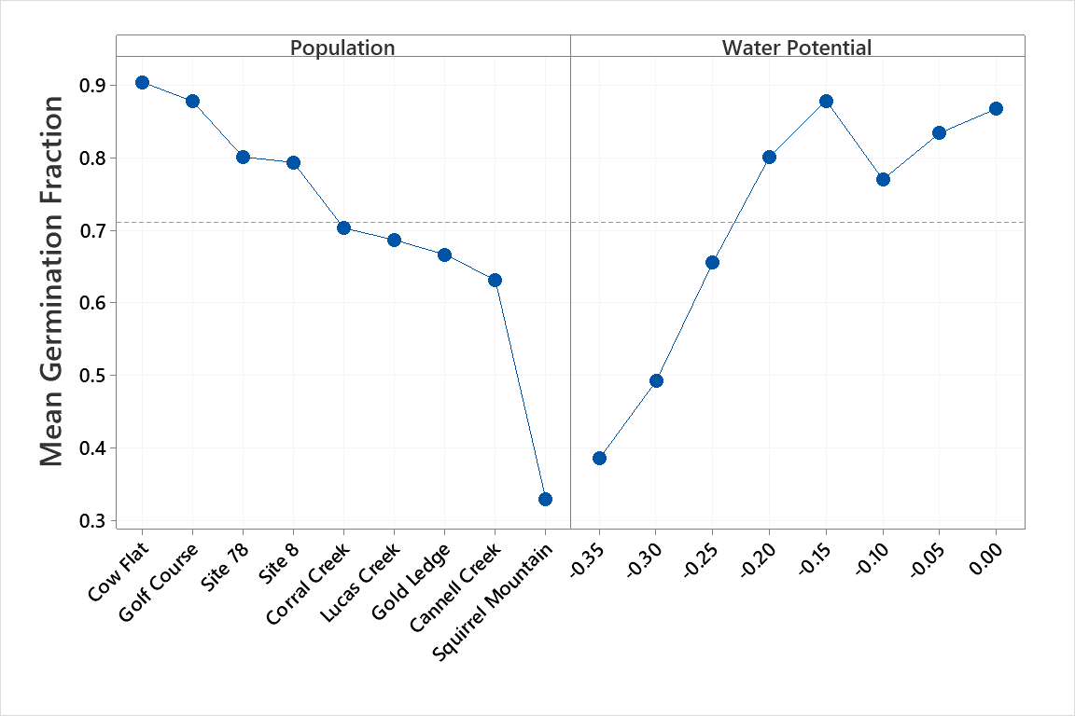

**Figure 3:** Main effects plots of final germination fraction for each population (left) and all water potential treatments (right). N = 10 for each population water potential treatment. Each point is the mean of two replicates except for Squirrel Mountain and Corral Creek, which each had one replicate.

The other seed germination parameters ranged broadly across populations (Table 1). Hydrotime () varied between 10.0 and 15.8, but among-population variation was not significant (F[7,7] = 0.98, p=.512) due to large variation between replicates. Mean base water potential () varied between -0.29 and -0.51, but like variation in , among-population variation was not significant (F[7,7] = 1.28, p=.377).

**Table 1:** Seed germination functional traits for a range of populations of *C. xantiana*. Calculated using repeat probit analysis, 2 replicates, with n=10 for each population water potential treatment. * denotes that only one replicate was carried out.

|  |  |  |  |
| --- | --- | --- | --- |
| Population | θH | *b* | Fitted mean germination fraction |
| Cannell Creek | 12.9 | -0.29 | 0.63 |
| Corral Creek* | 14.5 | -0.38 | 0.70 |
| Cow Flat | 12.3 | -0.51 | 0.91 |
| Gold Ledge | 12.0 | -0.32 | 0.67 |
| Golf Course | 10.0 | -0.44 | 0.88 |
| Lucas Creek East | 15.8 | -0.41 | 0.69 |
| Site 78 | 11.8 | -0.38 | 0.82 |
| Site 8 | 13.7 | -0.36 | 0.78 |
| Squirrel Mountain* | N/A | N/A | 0.33 |

Seed germination variables were independent of seasonal mean precipitation. Mean winter precipitation was not correlated with (*r*[8] = -0.294; p=.480), *b* (*r*[8] = 0.286; p = 0.492), or germination fraction (*r*[9] = 0.467; p = 0.205; Fig. 3). Mean spring precipitation also showed no correlation with (*r*[8] = 0.193; p = 0.648), *b* (*r*[8] = 0.409; p = 0.315), or germination fraction (*r*[9] = 0.271; p = 0.481; Fig. 3).

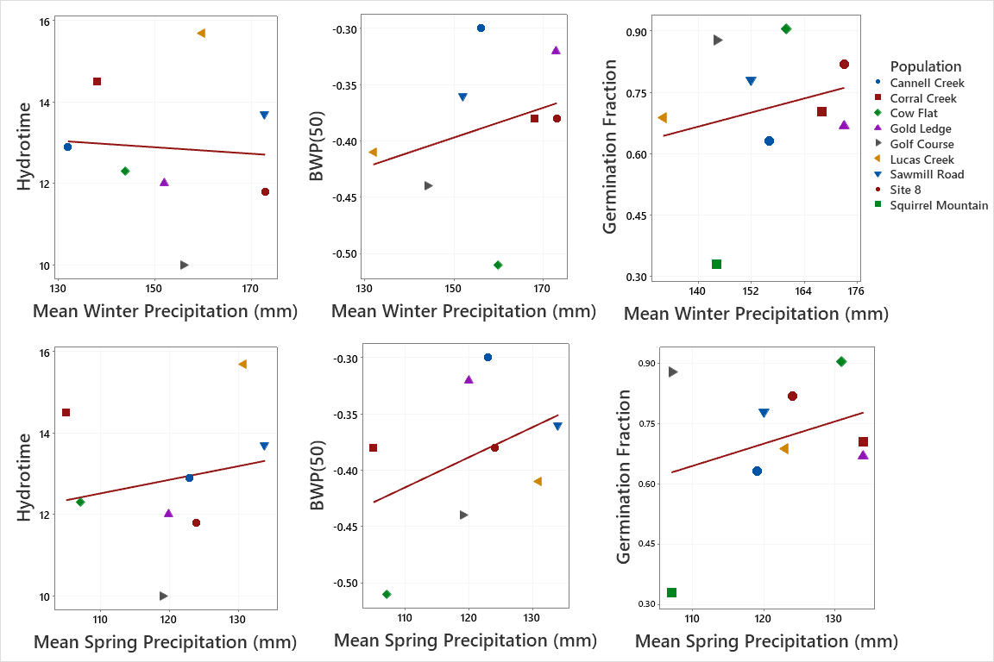

**Figure 4:** Scatterplots of θH (left), *b* (center), and germination fraction (right) vs. mean winter precipitation (upper row) and mean spring precipitation (lower row) for each population. Regression lines show trends, but none is statistically significant.

There was some evidence that variation in spring precipitation affects germination physiology. A negative correlation between and the CV of spring precipitation was marginally significant (r[8] = -0.695; p = 0.056; Fig. 5). The CV of spring precipitation did not correlate, however, with the other seed germination parameters, *b* (*r*[8] = 0.409; p = 0.315) or germination fraction (*r*[9] =0.261; p = 0.498; Fig. 5).

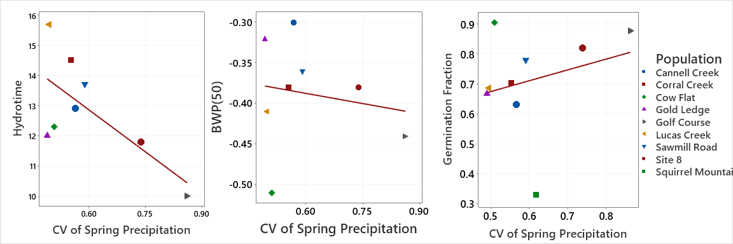

**Figure 5:** Scatterplot of (left), *b* (center), and germination fraction (right) vs. coefficient of variation in spring precipitation. The regression line at left is marginally significant (p = 0.056); the others are not.

Finally, there were hints that germination physiology correlates with variation in demography. Populations that have had recent reproductive failures had longer , higher , and lower germination fractions, on average (Fig. 6). Relationships between reproductive failure and the former two variables are suggestive but equivocal, as there is some overlap between the groups (: t[5] = -1.62; p = 0.165; : t[5] = -1.62; p = 0.159). The comparison analysis of germination fraction depends on whether the outlying Squirrel Mountain population is included. With that population it appears that germination fraction and reproductive failure are independent (t[5] = 0.66; p = 0.547). Without Squirrel Mountain, the germination fractions of the two sets of populations do not overlap at all, with lower germination fractions in those populations that had experienced reproductive failure (t[5] = 5.38; p = 0.006).

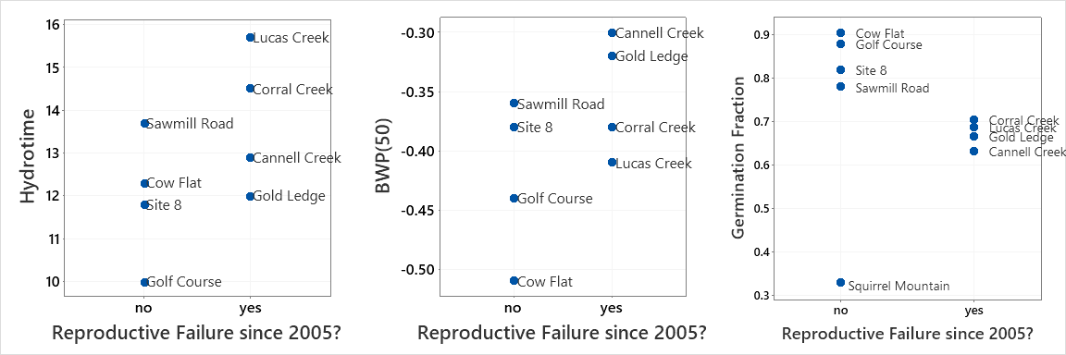

**Figure 5:** Individual value plots of (left), *b* (center), and germination fraction (right) in populations with and without reproductive failures since 2005.

**Discussion:**

There is evidence that seed germination traits vary between populations based on environmental and demographic variation. There were no significant differences in θH or *b* among populations of *C. xantiana*, but the germination fraction did vary significantly among populations (Fig. 2). This suggests that there are different strategies being used by populations, some populations germinating large fractions of seeds while others are more “cautious” (Question 1). There also appear to be correlations between the seed germination traits in question and some environmental and demographic features specific to the population (Fig. 3-6; Question 2). Coefficient of variation in spring precipitation was correlated with hydrotime, with shorter hydrotime in populations that had higher variation in precipitation. Additionally, there were lower germination fractions in populations that had experienced reproductive failure in the recent past. Taken together, these data show that germination strategies vary on the population level, and give preliminary evidence that variation is due to local adaptation.

While previous studies have found differences in hydrotime variables between species, I could not detect significant variation in θH and *b* across populations of *C. xantiana* ssp. *xantiana*. There have been multiple studies that have found variation in base water potential on an interspecies level (e.g., Huang et al., 2016; Liu et al., 2020; Castillo-Lorenzo et al., 2019). Castillo-Lorenzo et al. (2019) additionally found evidence of intra-specific variation in *Brassica* species for both θH and *b*. Tomczik (unpublished) has also shown evidence of differences in both θH and *b* betweentwo subspecies of *Clarkia xantiana*, ssp. *xantiana* and ssp. *parviflora*. It is likely that differences in these seed germination traits among populations within an individual subspecies would be less distinct due to the shorter evolutionary timeframe and continued gene flow between populations (Moeller et al., 2011). More research with both additional replicates, larger sample sizes at each water potential, and additional populations would clarify the nature of differences in seed germination among populations.

While there were no significant correlations between seasonal mean precipitation and germination traits, there was a trend that pointed to shorter θH for populations with a higher coefficient of variation in spring precipitation (Fig. 3). This means that in populations that experience higher variation in rainfall, there is a trend towards a lower time to germination after rainfall events. This appears to fit with previous studies of seed germination in arid climates. Duncan et al. (2019) argue that plants from arid environments often need to germinate quickly in order to take advantage of unpredictable precipitation schedules. On a smaller scale, Tomczik (unpublished) found shorter θH in *C. xantiana* ssp. *parviflora*, the subspecies that is distributed primarily in a more arid habitat. While this relationship between arid climate and shorter hydrotime has not been researched thoroughly in the past, these data appear to fit the strategy of cuing suggested in Donohue et al. (2010), as plants germinate quickly in response to water potentials higher than their base water potential. A hypothesis could be that plants from areas with more variable rainfall have adapted to have a faster cuing response to rainfall events, meaning that they need shorter periods of moisture in order to germinate. Geber and Eckhart (2005) argued that low, variable precipitation was an important contributor to local adaptation of early germination and flowering in *C. xantiana*. The fact that variation in precipitation also correlates with faster responses to rainfall events could suggest that seed germination is a mechanism behind these adaptations.

Finally, in populations that had a reproductive failure in the past 14 years, there was a trend towards higher *b* and higher θH, and a significantly higher dormancy fraction. These results suggest that there could be localized seed germination strategies of populations that experience variable conditions. The higher dormancy fraction suggests that the seeds are using a strategy of bet-hedging and waiting until future, possibly heavier rainfall events within a growing season or until a later, possibly rainier year to germinate. Bet-hedging has been shown to be an optimal strategy in plants from a wide range of habitats, but is particularly important for plants that have large levels of year to year environmental variation (Gremer et al., 2016; Donohue et al., 2010). Volis et al. (2002) have shown very similar data as this experiment, finding much higher rates of dormancy in populations of an arid annual plant *Hordeum spontaneum* when that population had experienced reproductive failure.

There is evidence that distinct strategies for germination have emerged that are specific to individual populations. Cuing and bet-hedging both appear to be important strategies as seeds attempt to maximize reproductive success. To gain a better understanding of the underlying traits behind these behaviors, a larger study of germination time courses that more closely follows the methods of Bradford (1990) would be beneficial. Beyond that, however, these data raise important questions to guide future analyses. One obvious path for future investigation is to expand the seed germination traits studied to include temperature and after-ripening effects. Liu et al. (2020) explain how these expanded “Population-Based Threshold” models can lead to thorough and verifiable models of how germination occurs under field conditions. This could potentially help answer outstanding questions about the relationship between niche and distribution in *Clarkia xantiana*. Additionally, it would be fascinating to analyze possible genetic links between germination traits within *Clarkia xantiana*. Huang et al. (2010) showed that there arequantitative trait loci that seem to correspond to germination traits. Moeller et al. (2011) showed that there is significant variation in population genetics within *C. xantiana*. If there are genetic underpinnings to these seed germination traits in *C. xantiana*, that would be further evidence of intraspecific natural selection on germination traits.

These data suggest several important conclusions about seed germination within populations of *Clarkia xantiana* ssp. *xantiana*. While hydrotime and base water potential did not significantly vary among the populations examined, there was clear evidence that populations had differing germination fractions. Hydrotime was correlated with coefficient of variation in spring precipitation, which suggests a faster cuing response in populations with less guaranteed rainfall. In populations that had experienced reproductive failure, there were lower germination fractions, evidence of increased bet-hedging. These results, in connection with the findings of Tomczik (unpublished) give evidence of differentiation in seed germination traits and strategies that are connected to local conditions on a much smaller scale than has been shown previously.

**Acknowledgements**

Thank you to Grinnell College’s MAP program and the National Science Foundation (DEB 1256316 & 1754157) for funding this project. Thank you to Professor Vince Eckhart for support and mentorship through all of the weirdnesses of doing research remotely. Finally, thanks to Kate Tomczik for helping with experimental design and reviewing drafts.

Literature Cited

Arène, F., Affre, L., Doxa, A., & Saatkamp, A. (2017). Temperature but not moisture response of germination shows phylogenetic constraints while both interact with seed mass and lifespan. *Seed Science Research,* *27*(2), 110-120. doi:10.1017/s0960258517000083

Austin, M. P. (1980). Searching for a model for use in vegetation analysis. *Vegetatio*, *42*(1-3), 11–21. doi: 10.1007/bf00048865

Baskin, C. C., and J. M. Baskin. 2014. *Seeds: Ecology, biogeography, and evolution of dormancy and germination*. Academic Press by Elsevier.

Bradford, K. J. (1990). A water relations analysis of seed germination rates. *Plant Physiology*, *94*(2), 840–849. doi: 10.1104/pp.94.2.840

Buckley, L. B., Waaser, S. A., Maclean, H. J., & Fox, R. (2011). Does including physiology improve species distribution model predictions of responses to recent climate change? *Ecology*, *92*(12), 2214–2221. doi: 10.1890/11-0066.1

Castillo-Lorenzo, E., Finch-Savage, W., Seal, C., & Pritchard, H. (2019). Adaptive significance of functional germination traits in crop wild relatives of *Brassica*. *Agricultural and Forest Meteorology*, *264*, 343–350. doi: 10.1016/j.agrformet.2018.10.014

Donohue, K., Casas, R. R. D., Burghardt, L., Kovach, K., & Willis, C. G. (2010). Germination, postgermination adaptation, and species ecological ranges. *Annual Review of Ecology, Evolution, and Systematics*, *41*(1), 293–319. doi: 10.1146/annurev-ecolsys-102209-144715

Dormann, C. F., Schymanski, S. J., Cabral, J., Chuine, I., Graham, C., Hartig, F., … Singer, A. (2012). Correlation and process in species distribution models: bridging a dichotomy. *Journal of Biogeography*, *39*(12), 2119–2131. doi: 10.1111/j.1365-2699.2011.02659.x

Duncan, C., Schultz, N. L., Good, M. K., Lewandrowski, W., & Cook, S. (2019). The risk-takers and -avoiders: Germination sensitivity to water stress in an arid zone with unpredictable rainfall. *AoB PLANTS,* *11*(6). doi:10.1093/aobpla/plz066

Eckhart, V. M., Geber, M. A., Morris, W. F., Fabio, E. S., Tiffin, P., & Moeller, D. A. (2011). The geography of demography: Long-term demographic studies and species distribution models reveal a species border limited by Adaptation. *The American Naturalist*, *178*(S1). doi: 10.1086/661782

Eckhart, V. M., Howland, M. R., Jennison, K., Kircher, B. K., Montgomery, D. M., Yuan, Y., & Geber, M. A. (2017). Contrasting soil-texture niches facilitate coexistence of two congeneric plants that differ in competitive ability. *AoB PLANTS*, *9*(6). doi: 10.1093/aobpla/plx066

Gauch, H. G., & Whittaker, R. H. (1976). Simulation of community patterns. *Vegetatio*, *33*(1), 13–16. doi: 10.1007/bf00055294

Gould, B., Moeller, D. A., Eckhart, V. M., Tiffin, P., Fabio, E., & Geber, M. A. (2013). Local adaptation and range boundary formation in response to complex environmental gradients across the geographical range of *Clarkia xantiana* ssp. *xantiana*. *Journal of Ecology*, *102*(1), 95–107. doi: 10.1111/1365-2745.12188

Grinnell, J. (1917). The niche-relationships of the California thrasher. *The Auk,* *34*(4), 427-433. doi:10.2307/4072271

Holt, R. D. (2009). Bringing the Hutchinsonian niche into the 21st century: Ecological and evolutionary perspectives. *Proceedings of the National Academy of Sciences*, *106*(Supplement 2), 19659–19665. doi: 10.1073/pnas.0905137106

Huang, X., Schmitt, J., Dorn, L., Griffith, C., Effgen, S., Takao, S., . . . Donohue, K. (2010). The earliest stages of adaptation in an experimental plant population: Strong selection on QTLS for seed dormancy. *Molecular Ecology,* *19*(7), 1335-1351. doi:10.1111/j.1365-294x.2010.04557.x

Huang, Z., Liu, S., Bradford, K. J., Huxman, T. E., & Venable, D. L. (2016). The contribution of germination functional traits to population dynamics of a desert plant community. *Ecology,* *97*(1), 250-261. doi:10.1890/15-0744.1

Hutchinson, G. E. (1957). Concluding Remarks. *Cold Spring Harbor Symposia on Quantitative Biology*, *22*(0), 415–427. doi: 10.1101/sqb.1957.022.01.039

James, A. R. M., Burnette, T. E., Mack, J., James, D. E., Eckhart, V. M., & Geber, M. A. (2020). Species‐specific variation in germination rates contributes to spatial coexistence more than adult plant water use in four closely related annual flowering plants. *Journal of Ecology*. doi: 10.1111/1365-2745.13408

Kramer, H. A. C., Montgomery, D. M., Eckhart, V. M., & Geber, M. A. (2011). Environmental and dispersal controls of an annual plant’s distribution: how similar are patterns and apparent processes at two spatial scales? *Plant Ecology*, *212*(11), 1887–1899. doi: 10.1007/s11258-011-9961-8

Liu, S., Bradford, K. J., Huang, Z., & Venable, D. L. (2020). Hydrothermal sensitivities of seed populations underlie fluctuations of dormancy states in an annual plant community. *Ecology,* *101*(3). doi:10.1002/ecy.2958

Moeller, D. A., Geber, M. A., & Tiffin, P. (2011). Population genetics and the evolution of geographic range limits in an Annual Plant. *The American Naturalist,* *178*(S1). doi:10.1086/661783

Morin, X., & Lechowicz, M. J. (2008). Contemporary perspectives on the niche that can improve models of species range shifts under climate change. *Biology Letters*, *4*(5), 573–576. doi: 10.1098/rsbl.2008.0181

Murphy, H. T., & Lovett-Doust, J. (2007). Accounting for regional niche variation in habitat suitability models. *Oikos*, *116*(1), 99–110. doi: 10.1111/j.2006.0030-1299.15050.x

Pearman, P. B., Damen, M., Graham, C. H., Thuiller, W., & Zimmermann, N. E. (2010). Within-taxon niche structure: niche conservatism, divergence and predicted effects of climate change. *Ecography*, *33*(6), 990–1003. doi: 10.1111/j.1600-0587.2010.06443.x

Peterson, A. T., & Holt, R. D. (2003). Niche differentiation in Mexican birds: using point occurrences to detect ecological innovation. *Ecology Letters*, *6*(8), 774–782. doi: 10.1046/j.1461-0248.2003.00502.x

Pfenninger, M., Nowak, C., & Magnin, F. (2007). Intraspecific range dynamics and niche evolution in *Candidula* land snail species. *Biological Journal of the Linnean Society,* *90*(2), 303-317. doi:10.1111/j.1095-8312.2007.00724.x

Rehfeldt, G. E., Ying, C. C., Spittlehouse, D. L., & Hamilton, D. A. (1999). Genetic responses to climate in *Pinus contorta*: Niche breadth, climate change, and reforestation. *Ecological Monographs*, *69*(3), 375. doi: 10.2307/2657162

Rodríguez, L., García, J. J., Carreño, F., & Martínez, B. (2019). Integration of physiological knowledge into hybrid species distribution modelling to improve forecast of distributional shifts of tropical corals. *Diversity and Distributions*, *25*(5), 715–728. doi: 10.1111/ddi.12883

Schupp, E. W. (1995). Seed-seedling conflicts, habitat choice, and patterns of plant recruitment. *American Journal of Botany,* *82*(3), 399–409. doi: 10.1002/j.1537-2197.1995.tb12645.x

Smith-Huerta, N. L. (1984). Seed germination in related diploid and allotetraploid *Clarkia* Species. *Botanical Gazette,* *145*(2), 246-252. doi:10.1086/337453

Volis, S., Mendlinger, S., & Ward, D. (2004). Demography and role of the seed bank in Mediterranean and desert populations of wild barley. *Basic and Applied Ecology,* *5*(1), 53-64. doi:10.1078/1439-1791-00192

Wiens, J. A., Stralberg, D., Jongsomjit, D., Howell, C. A., & Snyder, M. A. (2009). Niches, models, and climate change: Assessing the assumptions and uncertainties. *Proceedings of the National Academy of Sciences*, *106* (Supplement 2), 19729–19736. doi: 10.1073/pnas.0901639106

Wright, J. W., Davies, K. F., Lau, J. A., McCall, A. C., & McKay, J. K. (2006). Experimental verification of ecological niche modeling in a heterogeneous environment. *Ecology*, *87*(10), 2433–2439. doi: 10.1890/0012-9658(2006)87[2433:evoenm]2.0.co;2

Zimmermann, N. E., Edwards, T. C., Graham, C. H., Pearman, P. B., & Svenning, J.-C. (2010). New trends in species distribution modelling. *Ecography*, *33*(6), 985–989. doi: 10.1111/j.1600-0587.2010.06953.x

**Appendix A**

Environmental Data on *C. xantiana* ssp. *xantiana* Populations

**Table A1:** Environmental and demographic data from each population investigated. Data were measured from 2005-2018 with remote sensors for precipitation data and annual field surveys for data on reproductive failure.

|  |  |  |  |  |
| --- | --- | --- | --- | --- |
| **Population** | **Winter Precipitation (mm)** | **Spring Precipitation (mm)** | **CV of Spring Precipitation (mm)** | **Experienced Reproductive Failure?** |
| Cannell Creek | 132 | 123 | 0.57 | Yes |
| Corral Creek | 138 | 105 | 0.55 | Yes |
| Cow Flat | 144 | 107 | 0.51 | No |
| Gold Ledge | 152 | 120 | 0.49 | Yes |
| Golf Course | 156 | 119 | 0.86 | No |
| Lucas Creek | 160 | 131 | 0.49 | Yes |
| Site 8 | 173 | 124 | 0.74 | No |
| Site 78 | 173 | 134 | 0.59 | No |
| Squirrel Mountain | 138 | 105 | 0.62 | No |

**Appendix B**

Explanation of the Bradford (1990) model

**The Assumptions as I understand them:**

First, I’ll point out the assumptions of the model. “Hydrotime , mean base water potential and standard deviation of base water potential are assumed to be constant, intrinsic characteristics of the seed population.” Hydrotime is assumed to be the same for each seed in the population, but base water potential of individual seeds is not, it is assumed to be normally distributed throughout the population, with a mean and standard deviation Thus is the base water potential that is greater than the base water potentials of a certain slice of the population, the percentage . A seed population with a smaller , then, is a population that has a smaller range of base water potentials within the population. Finally, the model assumes that the cumulative germination time course (i.e. the time it takes to get to each of the germination percentages that a population reaches) approximates a cumulative normal distribution. This is because hydrotime relates time to germination (tg) to the difference in base water potential and the ambient water potential. Since base water potential is normally distributed, this means that the time courses will also be normally distributed, as the time to a specific germination percentage will vary with

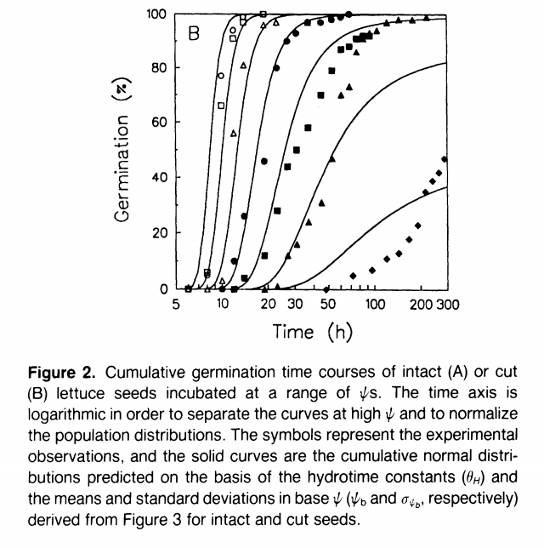

**The Model as I understand it:**

First, I think it is important to point out the goals of the model. Bradford says “this approach has the advantage that data from all germination percentages at all ambient water potentials () are utilized in a single regression.” Also, the endpoint is to find estimates of the three “intrinsic properties” of the seed population, which are hydrotime (, mean base water potential (), and standard deviation in base water potential within a population by using data from cumulative germination time courses, likely at multiple ambient water potentials. So we want to find a way to take our time course data to create a regression that can use as many data points as possible to create estimates of *,* , and .

The paper begins with the definition of hydrotime, equation 4 in Bradford:

which, when rearranged, becomes equation 6:

.

Because hydrotime is fixed for a population, this means that every time that germination percentage changes, you get another estimate of base water potential for that germination percentage. This is a good start, as we can then get a bunch of estimates of base water potential which we will use to find the intrinsic properties that we’re looking for. Right now, we can just plug in a random number in for hydrotime, and our estimates of base water potential will likely be off, but later we will work to find the optimal value that explains as much variation as possible.

What I couldn’t figure out for a long time, and I think the crux of the analysis, is how equation 6 related to equation 7, which is:

*­.*

First, we can focus on the left side of the equation. The probit function is meant to basically find the z score of a point on a normal distribution (i.e. it takes a probability from zero to one and outputs a z-score giving the number of standard deviations that probability is from the mean). In this case, the normal distribution it looks at is the cumulative germination time course for a population, which is the time it took to reach each germination percentage , from 0% to 100% (except 0% and 100% are omitted because probit doesn’t work well with either). Now, for each germination percentage , we have a z-score placing it in relation to the mean, which in this case corresponds to 50% germination.

Because the goal of this analysis is to try and find a linear model that can explain the relationship between data on percent germination and the “intrinsic properties” that are related to base water potential, and the left side is a measure of percent germination, we can assume that the right side of the equation will focus on , which we also know is normally distributed across the population. However, since the probit analysis created a z-score for each point, we now need to find the corresponding z-score of base water potential, so that we can find a nice easy linear regression. We can just follow the formula for finding a z-score:

or in English, point minus mean over standard deviation. We assumed that the mean base water potential (and standard deviation of base water potential were intrinsic, fixed characteristics of the population, so we can say that

.

We can now relate the two normal distributions and , in order to attempt to determine whether there is a linear relationship between the two.

.

note: because equation 6 says that Bradford writes this in equation 7 as *­.* This allows for some interesting extensions of the results, but it isn’t important for right now.

However, as we discussed earlier, the estimates we have for were found by just plugging in a random value for into the equation . This means that the values of that we have are almost definitely not the values that give us the most explanatory power. By varying the value, we can attempt to find the values for that explain the most variation in . We do that with a computer, which tries a ton of different values until it finds the best one. This process can be seen in the figures below, going from a line that has a very poor fit to one that has a relatively good fit. In this way, we find the optimal value for hydrotime .

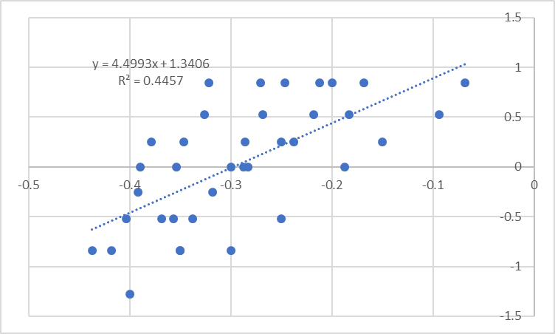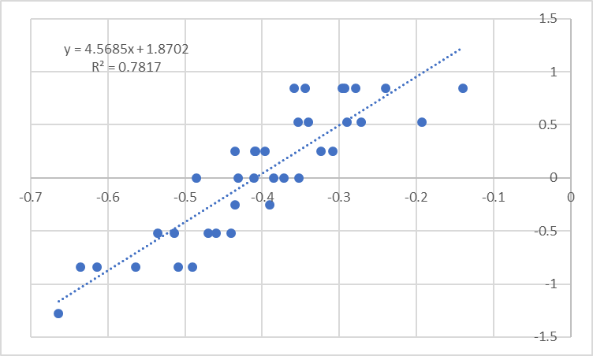

Now we have one of the three intrinsic properties that we were hoping to determine. However, we still need to determine the mean base water potential and standard deviation in base water potential . To find the mean base water potential, we can use the fact that at the mean germination percentage, will always equal 0, as the z-score of the mean is by definition 0. Thus, all we need to do is find the x-intercept and we have a value for Finally, a feature of probit plots is that the standard deviation of the x characteristic, in this case base water potential, can be found by taking the inverse of the slope. I don’t quite understand how that works out mathematically, but it makes sense, as for example a near-vertical line would mean that the x variable changed very little over the distribution and would output a standard deviation close to zero. Thus, we can just take the inverse of the slope of the calculated regression line and we have our third intrinsic property .

**Probit Analysis in Excel**

**Data Entry:**

The data entered into the spreadsheet should be the germination data for each time recorded, and the number of non-viable seeds found at the end of the experiment. I had multiple replicates, but ran each one separately, as this gave a better estimate of the uncertainty of these calculations between replicates, and is what many papers have done in the past (e.g., Liu et al. (2020); Castillo-Lorenzo et al. (2019)).

**Time Course:**

The worksheet will automatically create a cumulative time course from the data in each Fraction column. These cumulative time courses are found in row 46-61 and are determined by extracting each unique value in the Fraction row, which are the unique germination percentages ,then matching each one with the corresponding time to germination .

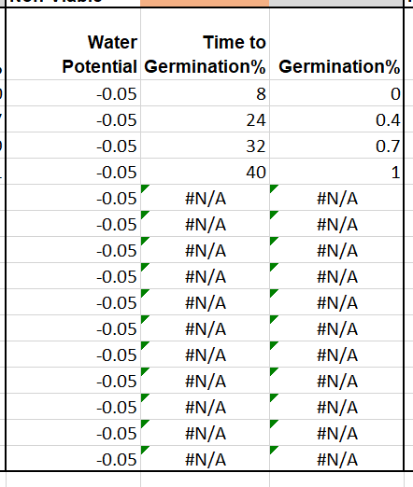

**Optimization:**

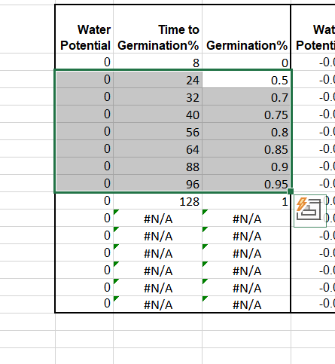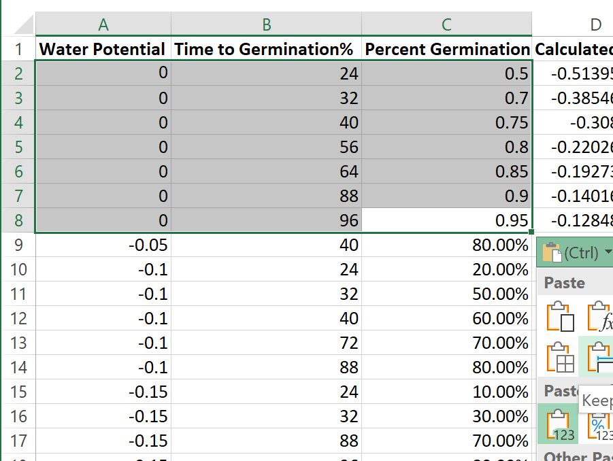Once the data are entered and time course data have been calculated, the data can be transferred to the Optimization sheet. It should work so that you can copy and paste each time course into the Optimization sheet, making sure to only paste values, not the formulas used to calculate them. Make sure to omit the germination percents of 0% and 100%, as the probit won’t be able to handle those since it only deals with percentages greater than 0% and less than 100%.

Once the data have been transferred, there should be estimates of Calculated BWP (calculated using equation 6 in Bradford, in column D. The ambient water potential and time to germination% are coming from the inputted data, but the hydrotime ( is from the estimate in cell G6 and is what we will eventually optimize. The inputted percent germination data that were brought into the sheet are used to calculate Probit(g), which uses the NORM.INV function to create estimates of the z-scores for each percent germination.

Once all of these have been calculated (which should happen automatically as they are inputted), then the optimization starts. For this, the Solver plugin needs to be added to Excel if it isn’t already. You can tell if you have it by going to Data->Analyze->Solver, and if you don’t see it I’d just look up a tutorial on how to add it, as I don’t really know the easiest way to do it.

The way Solver works is by setting one cell as an objective, and then varying the value in a different cell in order to maximize or minimize the value of the target cell. In this case, we want to maximize the R2 value of the regression line of (maximizing R2 wasn’t mentioned directly in Bradford, but Liu et al. (2020) did it this way). We do this by first creating that regression line, which is calculated and represented by the statistics in cells G12:J17 using the LINEST function. *Important note: You’ll need to change the cells that get included in the LINEST regression, as there will almost certainly be more or fewer rows included in the new time courses. To do this, since LINEST is an array function, you have to select all of the regression statistics, click on the formula bar and edit the rows selected, then press CTRL-Shift-Enter.

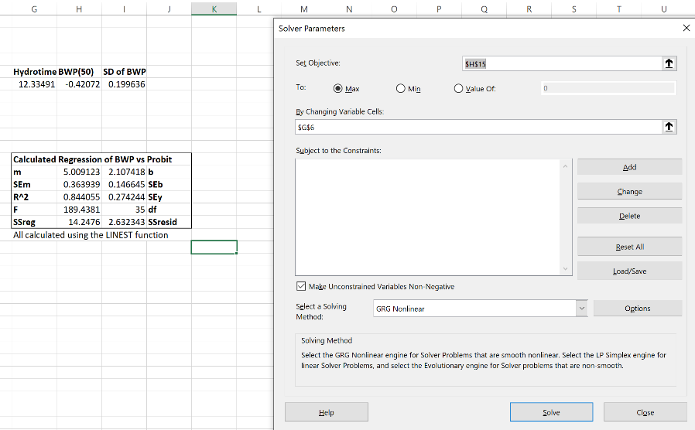Then, go in to Data->Analyze->Solver. We want our objective to be R2, so that should be set to H15, and we want to vary hydrotime, so enter G6 into that field. In Liu et al. (2020), they use the GRG Nonlinear solving method, so that is also what I used. Then, just click solve, and there should be a popup, click OK and you should have an optimized result for hydrotime. The estimates of mean base water potential (and are also determined, in the BWP(50) and SD of BWP cells.